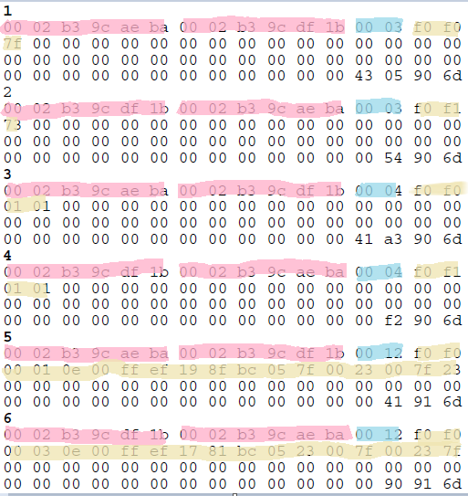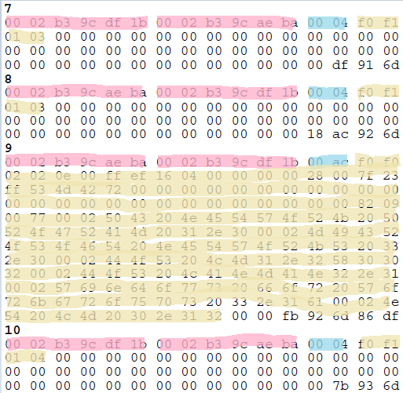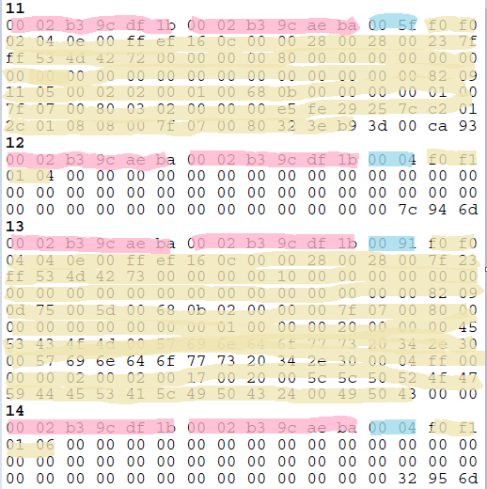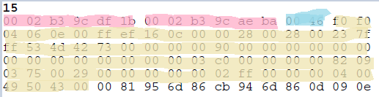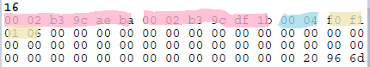

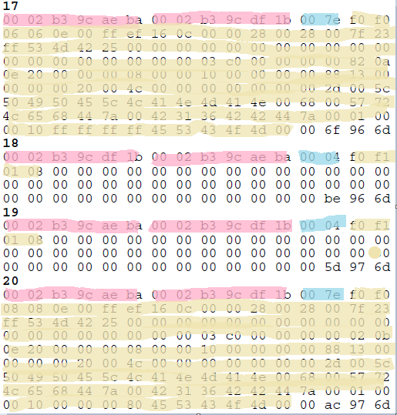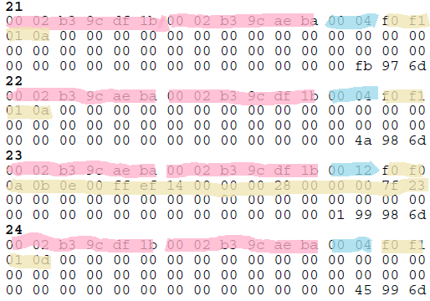

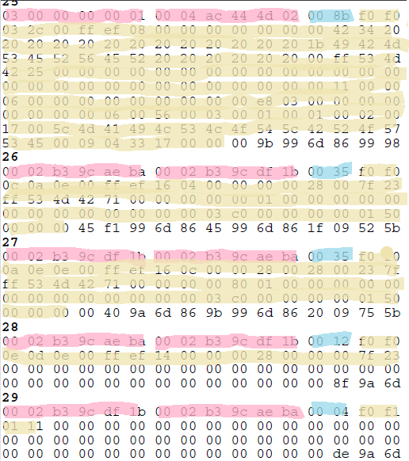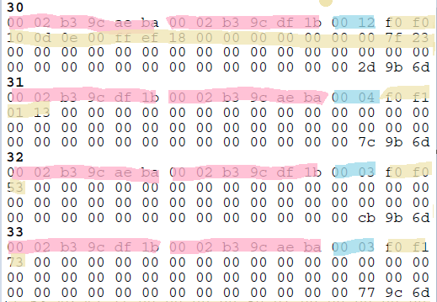

Alicia = 0002b39caeba Beto = 0002b39cdf1b

|  |  |  |  |  |  |  |  |  |  |
| --- | --- | --- | --- | --- | --- | --- | --- | --- | --- |
| No | Tam. | Control | Tipo | N(s) | N(r) | P/F | C/R | SAPo | Dir. |
| 1 | 3 | 011 1 11 11 | U | M=15 | | 1/c | SABME | F0 | Alicia |
| 2 | 3 | 011 1 00 11 | U | M=12 | | 1/f | UA | F1 | Beto |
| 3 | 4 | 0000 00 01  0000000 1 | S |  | 0 | 1/c | RR | F0 | Alicia |
| 4 | 4 | 0000 00 01  0000000 1 | S |  | 0 | 1/f | RR | F1 | Beto |
| 5 | 18 | 0000000 0  0000000 1 | I | 0 | 0 | 1/c |  | F0 | Alicia |
| 6 | 18 | 0000000 0  0000001 1 | I | 0 | 1 | 1/c |  | F0 | Beto |
| 7 | 4 | 0000 00 01  0000001 1 | S |  | 1 | 1/f | RR | F1 | Beto |
| 8 | 4 | 0000 00 01  0000001 1 | S |  | 1 | 1/f | RR | F1 | Alicia |
| 9 | 172 | 0000001 0  0000001 0 | I | 1 | 1 | 0 |  | F0 | Alicia |
| 10 | 4 | 0000 00 01  0000010 0 | S |  | 2 | 0 | RR | F1 | Beto |
| 11 | 95 | 0000001 0  0000001 0 | I | 1 | 1 | 0 |  | F0 | Beto |
| 12 | 4 | 0000 00 01  0000001 0 | S |  | 1 | 0 | RR | F1 | Alicia |
| 13 | 145 | 0000001 0  0000001 0 | I | 1 | 1 | 0 |  | F0 | Alicia |
| 14 | 4 | 0000 00 01  0000011 0 | S |  | 3 | 0 | RR | F1 | Beto |
| 15 | 70 | 0000001 0  0000011 0 | I | 1 | 3 | 0 |  | F0 | Beto |
| 16 | 4 | 0000 00 01  0000011 0 | S |  | 3 | 0 | RR | F1 | Alicia |
| 17 | 126 | 0000011 0  0000011 0 | I | 3 | 3 | 0 |  | F0 | Alicia |
| 18 | 4 | 0000 00 01  0000100 0 | S |  | 4 | 0 | RR | F1 | Beto |
| 19 | 4 | 0000 00 01  0000100 0 | S |  | 4 | 0 | RR | F1 | Alicia |
| 20 | 126 | 0000100 0  0000100 0 | I | 4 | 4 | 0 |  | F0 | Alicia |
| 21 | 4 | 0000 00 01  0000101 0 | S |  | 5 | 0 | RR | F1 | Beto |
| 22 | 4 | 0000 00 01  0000101 0 | S |  | 5 | 0 | RR | F1 | Alicia |
| 23 | 18 | 0000101 0  0000101 1 | I | 5 | 5 | 1/c |  | F0 | Alicia |
| 24 | 4 | 0000 00 01  0000110 1 | S |  | 6 | 1/f | RR | F1 | Beto |
| 25 | --- | --- | --- | --- | --- | --- | -- | -- | --- |
| 26 | 53 | 0000110 0  0000101 0 | I | 6 | 5 | 0 |  | F0 | Alicia |
| 27 | 53 | 0000101 0  0000111 0 | I | 5 | 7 | 0 |  | F0 | Beto |
| 28 | 18 | 0000111 0  0000110 1 | I | 7 | 6 | 1/c |  | F0 | Alicia |
| 29 | 4 | 0000 00 01  0001000 1 | S |  | 8 | 1/f | RR | F1 | Beto |
| 30 | 18 | 0001000 0  0000110 1 | I | 8 | 6 | 1/c |  | F0 | Alicia |
| 31 | 4 | 0000 00 01  0001001 1 | S |  | 9 | 1/f | RR | F1 | Beto |
| 32 | 3 | 100 1 00 11 | U | M = 16 | | 1/c | SNRM | F0 | Alicia |
| 33 | 3 | 011 1 00 11 | U | M = 12 | | 1/f | UA | F1 | Beto |